**Pre-requisites:**

* NGE share path access.
* LASS access to install & run software’s.
* Access to GitHub and NGE source code repositories.

**Softwares Needed:**

* Mulesoft Anypoint Studio 6.4.2 → No installation

Path → \\livpvnasci01\share\eStart Support Team\Next Generation eStart\NGE Development Program 2014-2017\Gate 2\Softwares\Mulesoft

* Apache Maven 3.6.3 → No installation

Path → \\livpvnasci01\share\eStart Support Team\Next Generation eStart\NGE Development Program 2014-2017\Gate 2\Softwares\Mulesoft

**GitHub Repo: (Always download develop branch)**

<https://github.aig.net/commercial-it-integration>

hip2-comsvc-domain-develop(Download it in zip file and unzip it, place it in C Drive)

nge-submission-data-exp-api-develop

nge-submission-management-exp-api-develop

**Steps:**

* Download all the aforementioned software’s on C:/> drive.
* Add the jdk path in AnypointStudio.ini (Configuration file - available inside the software package)

|  |
| --- |
| -vm  C:/Program Files/Java/jdk1.8.0_191/bin (path may differ)  -XX:MaxPermSize=1024m |

* Open Anypoint Studio in Admin mode by right click and select Run as Administrator and ensure to create a workspace on C:/> drive.
* Validate whether proper JRE is being referred in the workspace. If not, point to the JRE location.
  + Window →Preferences→Installed JREs
  + JRE Home → C:\Program Files\Java\jdk1.8.0_191 (path may differ)
  + JRE Name → jdk1.8.0_191

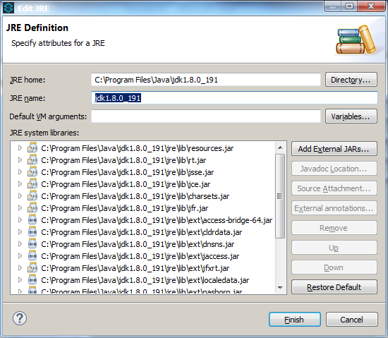

* Set the maven installation directory and **test maven configuration**. It should be successful.
  + Window →Preferences→Maven
  + C:\padma\soft\apache-maven-3.6.3 (path may differ)

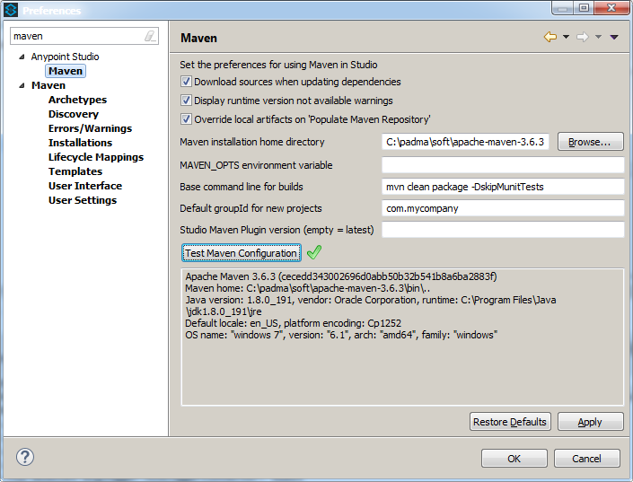

* **Import the Mule project into Anypoint Studio IDE via pom.xml:**
* Go to <https://github.aig.net/commercial-it-integration> and search for required package- open it.
* A page get displayed with package, there you will find an option called Code- click that dropdown and copy URL.
* Now open Github Desktop, go to File 🡪 Clone repository🡪URL. Paste the url which you have copied in URL field and choose a path in C drive where that package has to save and click on clone.
* Current repository will show you the package name that you have downloaded.
* Go to current branch and select Develop.
* Click on fetch origin.
* A page get displayed which is shown below

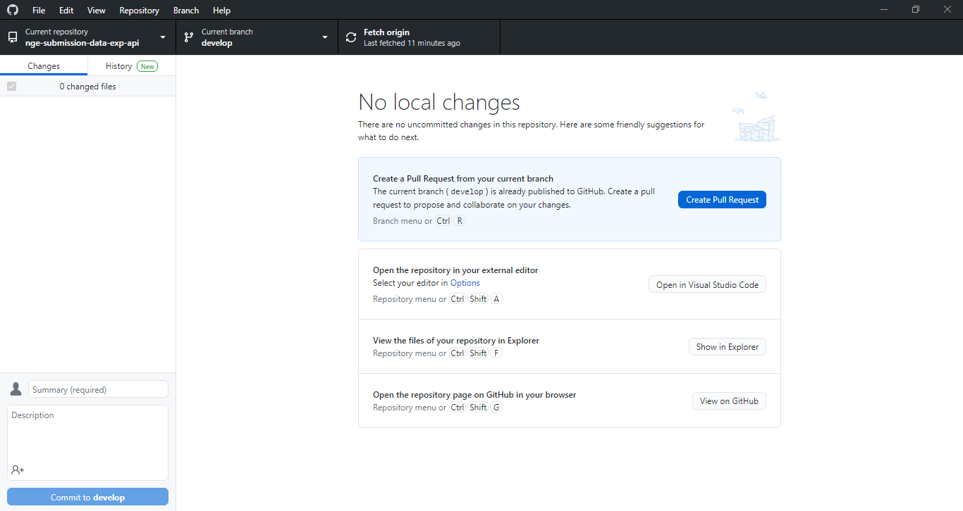

Then click on show in folder, it will take you to the folder where the package got saved.

* Copy the path of folder
* Now open Anypoint studio, Right click on package Explorer and select Import → Anypoint Studio → Maven-based Mule Project from pom.xml.
* Locate the pom.xml corresponding to the project being imported, check the box Copy Project into Workspace and finish. (Or)
* Click on 3 dots shown in below image beside pom file and paste the folder path in which your package is contained🡪Select POM file🡪 click on checkbox🡪 finish.

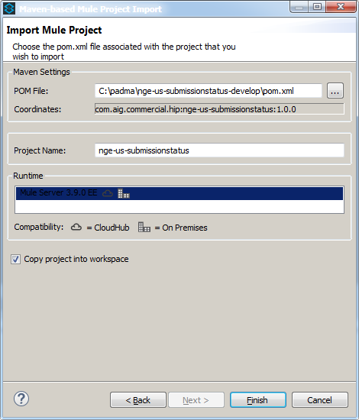

* If the project has any compilation issue with maven, update the project dependencies.
  + Right click on package → Mule → Update Project Dependencies
* Keep the conf files in below location.
  + Mule conf folder → H:\Softwares\AnypointStudio\plugins\org.mule.tooling.server.3.9.0.ee_6.4.2.201712051241\mule\conf (path may differ and tooling plugin may have different number)

|  |
| --- |
|  |

* Create a folder in C:/> drive and keep the keyfile.properties file.
  + KeyFile folder → C:\padma\Mule\KeyFile (path may differ)

|  |
| --- |
|  |

* Keep the Jackson libraries in below location.
  + Mule lib\boot folder → H:\Softwares\AnypointStudio\plugins\org.mule.tooling.server.3.9.0.ee_6.4.2.201712051241\mule\lib\boot (path may differ and tooling plugin may have different number)

|  |
| --- |
|  |

* <https://github.aig.net/commercial-it-integration/hip-jar-3.9.0-patch/tree/master/lib>
* \\livpvnasci01\share\eStart Support Team\Next Generation eStart\sundar\HIP2 JArs\user

Go to above URL Download all the jars and place it in below mentioned path or go to above mentioned path🡪 copy all the jars and paste it in below mentioned path

<< your AnypointStudio folder>> \plugins\org.mule.tooling.server.3.9.0.ee_6.4.2.201712051241\mule\lib\user

* To run the project, follow below steps.
* Run → Run Configurations → Mule Application with Maven (configure)
* Under Maven Settings Tab → -DskipTests=true
* Under Argument Tab → VM arguments → -XX:PermSize=128M -XX:MaxPermSize=256M -DskipTests -Dmule.env=dev -Dmule.propertiesFolder=C:/KeyFolder/Mule -Dspring.cloud.config.uri=https://springcloudconfignonprod.apps.nprd-pcf.aig.net(In place of **C:/KeyFolder**, mention the path where keyfolder is located in your system)
* Run the defined configuration.

**To Debug:**

* + Run → Debug Configurations → Mule Application with Maven (configure)
  + Under Maven Settings Tab → -DskipTests=true
  + Under Argument Tab → VM arguments → -XX:PermSize=128M -XX:MaxPermSize=256M -DskipTests -Dmule.env=dev -Dmule.propertiesFolder=C:/KeyFolder/Mule -Dspring.cloud.config.uri=https://springcloudconfignonprod.apps.nprd-pcf.aig.net
  + Debug the defined configuration.